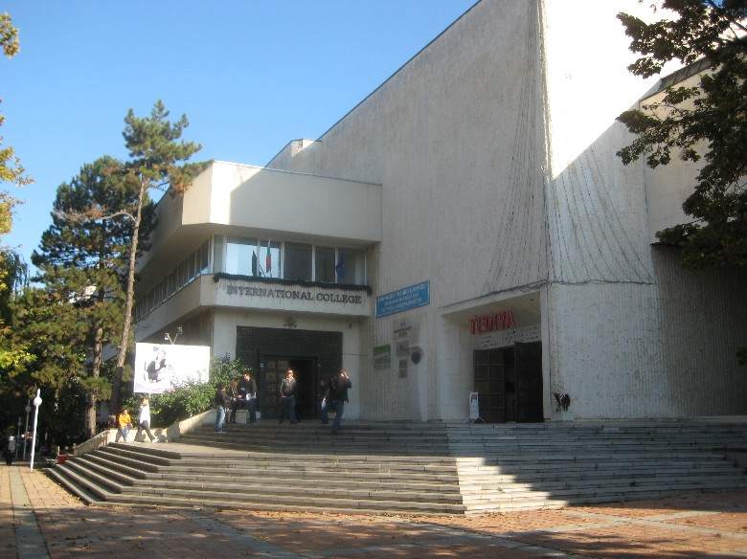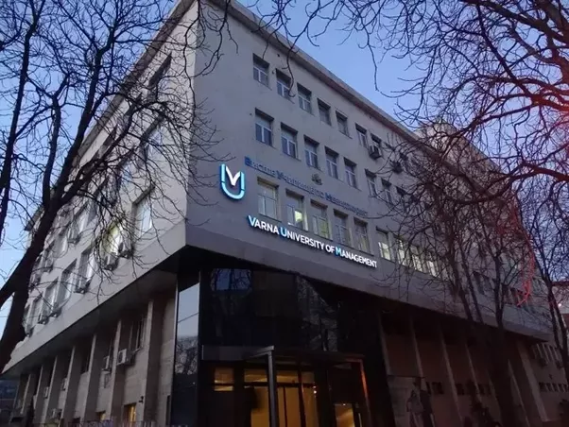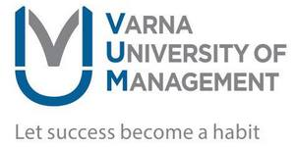

13A Oborishte St 9000 Varna  
Email: erasmus@vumk.eu   
Telephone: +359 58 65 56 38  
Fax: +359 58 605 760

**APPLICATION PROCEDURES**

**Deadlines For Student Mobility 2018/2019**

* for mobility starting in autumn 2018: 15th July 2018
* for mobility during the 2nd semester of 2018/2019: 30th November 2018.

**Application Documents Set**

1. Application Form
2. Motivation Letter prepared by the student
3. Transcript of Records issued by the sending institution
4. Proof of English language proficiency corresponding to at least B1 level.
5. CV in Europass format (only in case of student mobility for placement)
6. Learning Agreement for Traineeship (only in case of incoming student mobility for placement)
7. Copy of the student’s European Health Insurance Card (EHIC). Non-EU citizens are expected to provide a copy of medical insurance valid for the EU and Bulgaria for the period of the planned Erasmus+ mobility.

*For details, please refer to [www.erasmusplus.vum.bg](http://www.erasmusplus.vum.bg)

**CONTACTS**

**Christina Armutlieva**

Director of International Cooperation, Erasmus+ Institutional Coordinator

Institutional internationalization policies, international academic cooperation and bilateral agreements

Email: [christina.armutlieva@vumk.eu](mailto:christina.armutlieva@vumk.eu)

Tel: +359 52 300 680

**Rosita Koleva**

International Cooperation Coordinator

Incoming and outgoing student and staff mobility

Email: [erasmus@vumk.eu](mailto:erasmus@vumk.eu)

Tel.: +359 58 655 638

Mob.: +359 886 744 433

**Kalina Stoyanova**

International Cooperation Coordinator

Incoming and outgoing student and staff mobility

Email: [erasmus@vumk.eu](mailto:erasmus@vumk.eu)

Tel.: +359 58 655 638

Mob.: +359 888 358 688

**ACADEMIC CALENDAR 2018/2019**

* **1st Semester**: 25th September 2018 –25th January 2019
* **2nd Semester**: 28th January 2019 – 17th May 2019
* Christmas holidays:  23rd December 2018 – 2nd January 2019
* **3rd (Summer) Semester**: 3rd June 2019 – 13th September 2019

*Each semester corresponds to 30 ECTS.

**OFFICE HOURS**

* Monday – Friday – 8:30 am – 5:00 pm
* Saturday – Sunday - closed

**VARNA UNIVERSITY OF MANAGEMENT**

Varna University of Management is an international business school located in Europe, Bulgaria with campuses in Varna, Dobrich, and Sofia.

Through the Erasmus+ International Credit Mobility programme, VUM welcomes incoming students for studies who are full-time students at VUM partner universities located in various Partner Countries for which the institution has managed to attract mobility funding.

Additionally, VUM welcomes every year incoming students for studies or placement who are full-time students at one of the more than 80 partner universities of VUM located in near 20 Programme Countries from the EU, Norway and Turkey.

FACT SHEET 2018